Individual report: Joker Athletics
Student: Michael Skeats
B-Number: B01030100
Group 37
Individual components: class schedule page + membership pages

Introduction
Group 37 is comprised of 4 individual members Logan Simpson, Fionn Slavin, Aadhinath shibukumar and Michael Skeats. As a group we decided to make a gym the subject of our group project as this type of website would allow us to fully show our understanding of jQuery and JavaScript techniques alongside proper uses of CSS to properly style our website. Each member of the group was assigned one page of the website to develop with me taking the membership pages and the class schedule page as these pages would allow me to showcase my knowledge of JavaScript validation and jQuery.
Class schedule page
The purpose of the classes page is to display the schedule of classes offered by the gym and to offer a description of each class. I used this page to showcase usage of a jQuery function to show and hide text describing each individual class.
jQuery
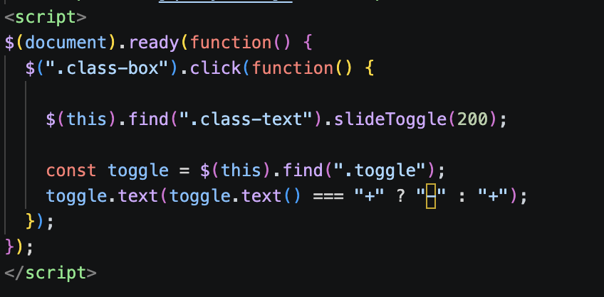

The above jQuery function is responsible for opening and closing each class box to show and hide text that is inside each class box. The function begins with $(document).ready (function) which ensures that the function can only run when the DOM has fully loaded each element in the page and that the page is ready to be manipulated by the function. Ensuring that each element is fully loaded prevents the event listeners inside the function from not functioning due to the elements not existing inside the DOM thus ensuring that the class boxes that are manipulated using the function are present to be manipulated.

The $(class.box) selects all elements of the html with the class class-box while the .click(function() adds a click event handler to each element inside the class-box class which ensures that if a user clicks on any class box the function will run properly.
Instance of Class-box in html:
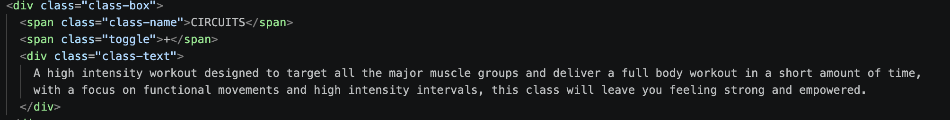
The $(this) part of the jQuery is the event handler in jQuery and refers to the specific element of class-box that triggers the event. Additionally, this enables the use of the .find() method which is used to find the descendant of class-box element, which in this case is Class-text which is then revealed using the .slideToggle portion of the function. This line of code ensures the only the class-box element that was clicked is affected by the function and not all instances of class-box.
The .slideToggle(200) is a JQuery animation that slides the element down and shows it if it is hidden (class-text begins as hidden) and if visible it slides the element up and hides it. The (200) is the duration of the animation.
Class-box element unopened:

Class-box element opened:

The final line of the jQuery code beginning with toggle.text is responsible for changing the “+” toggle of the unopened class-box to a “- “when opened using ternary operators to check what the toggle currently shows.

Navigation Bar
Navigation bar in HTML:
Diagram 1
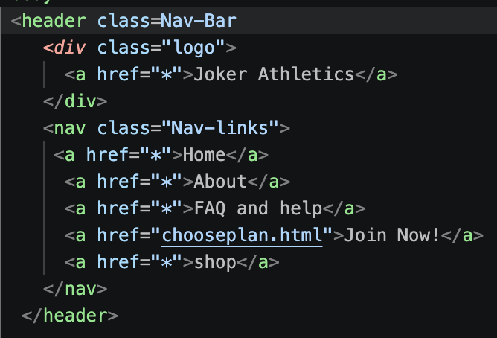
Navigation bar in CSS:
Diagram 2
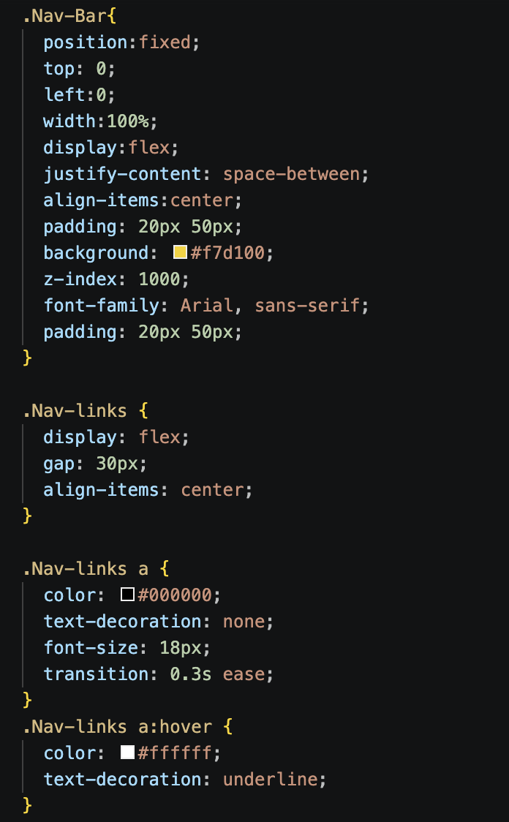
This navigation bar serves as the primary method for users to navigate the website with each link leading to a separate portion of the website (in the screenshot the other webpages are un-connected with “*” as a placeholder due to not having access to the pages of my fellow group members, although “Chooseplan.html” is a part of my membership pages).
The implementation of my navigation bar will increase the accessibility as the use of <header> and <nav> will enable Screen readers to identify the navigation bar automatically thus allowing blind people to easily navigate the website. Additionally, the size of the links makes it more accessible as they are large enough for those who may have motor issues to comfortably click their desired link. Furthermore, the contrast between the text and background supports accessibility guidelines set out by the WCAG (web content accessibility guidelines). The pairing of a bold background color and dark text makes sure that users with poor vision and colour blindness can still comfortably navigate the website.

Membership pages
My membership page has been split into three individual pages with each focusing on an individual aspect of the process of signing up for a gym membership being Membership details, choose plan and payment details.

Membership Details
The purpose of the Member details page is to collect basic information about the member such as full name, email, city, phone number.
Validation
The purpose of the validation script ensures that all user input information is completed and formatted correctly before the user can progress further in the joining process, ensuring that all information is correct and compliant with GDPR law which require user information to be correct and up to date thus preventing the possibility of fines and loss of reputation. Additionally, proper validation improves the reliability of the stored data allowing for accurate billing practices.
How it works
Diagram 1
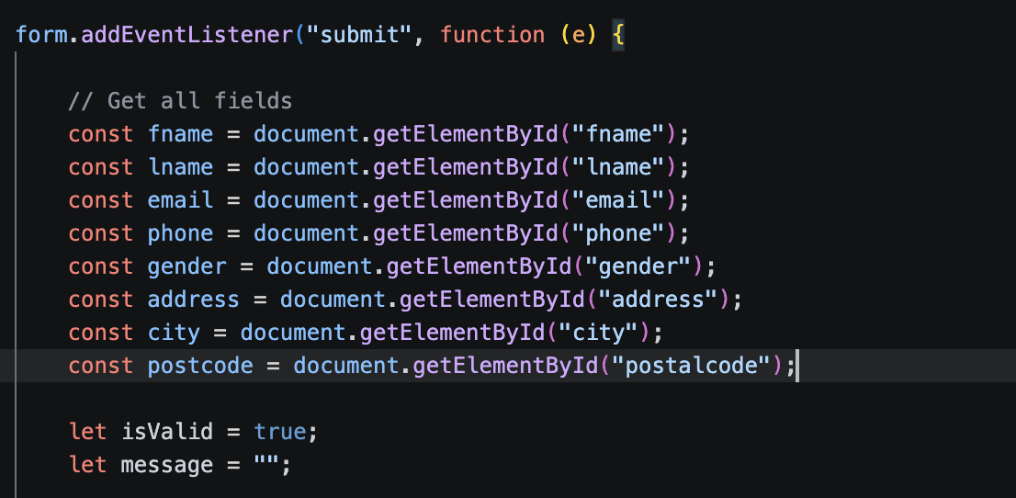
Diagram 2
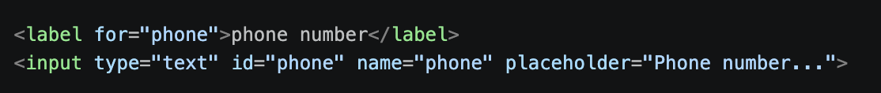
My validation begins by retrieving each value by its ID which is stated in the html code (Diagram 2) which ensures that each field can be accessed directly, ensures that each validation function works with the correct input and avoids any ambiguity that may occur. While the “Let isvalid = true” ensures that if any field fails validation that it becomes false. The “let message” line accumulates all the error message from fields that fail validation thus on submit it returns a full list of error messages therefore increasing usability as it prevents users from repeatedly submitting the form to discover individual errors.
Diagram 3
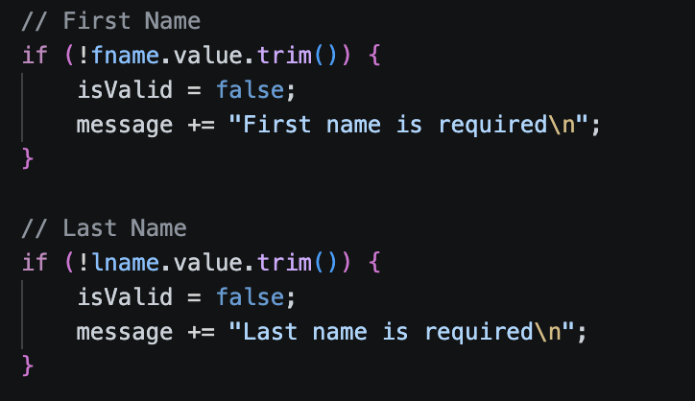

The field-by-field validation is done largely by a combination of “value.trim” which removes any whitespace present in the user’s submission while keeping the submission together (diagram 3). Furthermore, regular expressions are also used in my validation to ensure the presence of certain characters/ number of characters in the user’s submission (diagram 4/5). The validation for gender, city, address, postal code and gender validation fields work in the same way as the name fields.
Diagram 4
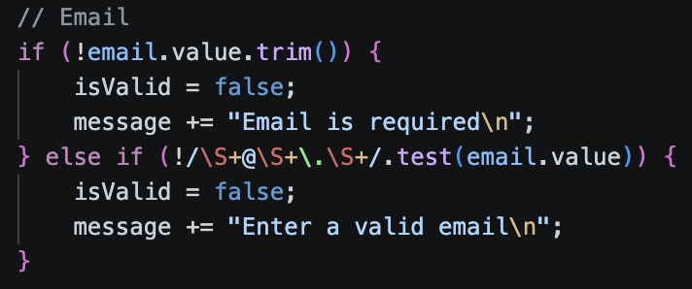
The email validation (Diagram 4) is comprised of 2 checks. The first checks if the required field has been filled in by the user ensuring that there is a input that can be checked by the secondary check. The secondary check uses regex to ensure the email contains characters before and after the @ symbol, “.” And a domain extension (gmail.com, outlook.com). these checks combined together will effectively screen out any invalid email inputs.
Diagram 5
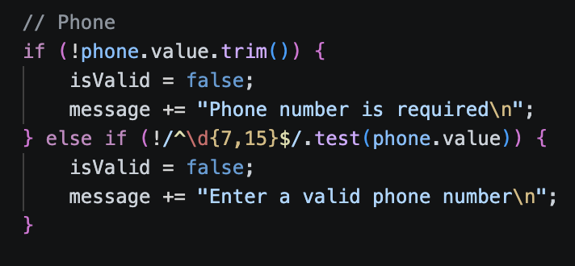

The Phone number validation (Diagram 5) works in a similar way to my email validation shown in Diagram 4, though it is comprised of only one check that utilises regex that makes sure the input contains only digits and contains between 7 and 15 digits thus preventing excessively short/ long phone numbers, letters and symbols form being inputted successfully therefore ensuring consistent formatting.
Diagram 6
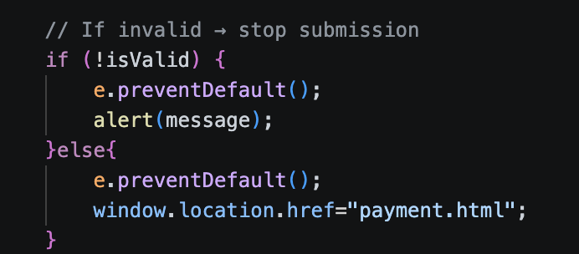
Diagram 7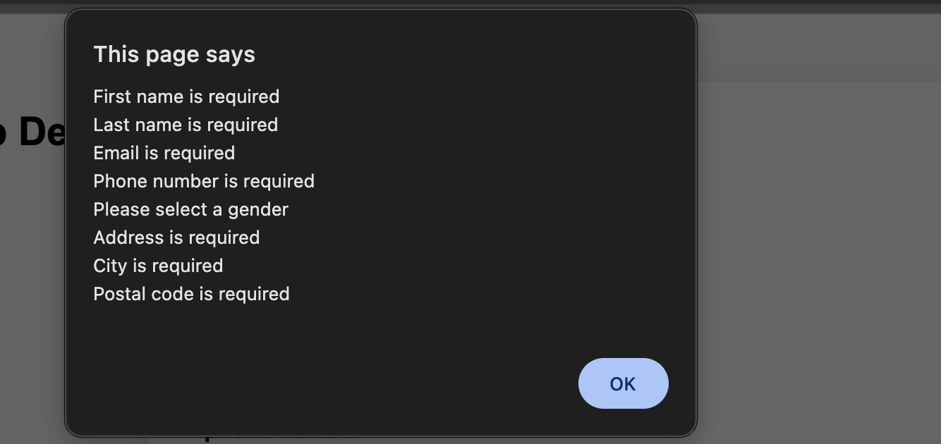

The segment of code shown in Diagram 6 is responsible for handling submissions onto the file with the first half handling invalid submissions by utilising “Preventdefault” to stop the form submitting and displaying any accumulated error messages (Diagram 7) for the user to then complete properly thus preventing any inaccurate data from entering the system which would undermine the data integrity of the business. The second half of the code shown in Diagram 6 deals with a successful submissions which upon completion redirects the user to the payment page therefore ensuring only validated data makes it to the payment page.

Diagram 8
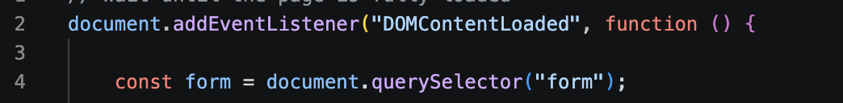
The code on line 2 of diagram 8 is simply responsible for ensuring that all the content has loaded before the function begins to execute ensuring that all the fields have been loaded and are available to be manipulated. While line 4 simply retrieves the form using a query selector.

Payment/ Checkout page validation
The handling of my checkout validation is very similar to how the member detail validation was handled although with some differences because as seen in diagram 9 I have still used regex to ensure that valid characters fall within a certain acceptable range. Additionally, the beginning of my validation (Diagram 10) as it will wait for the content in the DOM to be loaded before beginning the function alongside selecting and listening for the form to submit before running the function. Thirdly, diagram 11 works similarly to diagram 3 although it only checks for an empty field instead of removing whitespace. However, I have handled my end validation somewhat differently as in diagram 12 it checks if any errors have occurred and prevents submission if any are detected.
Diagram 9
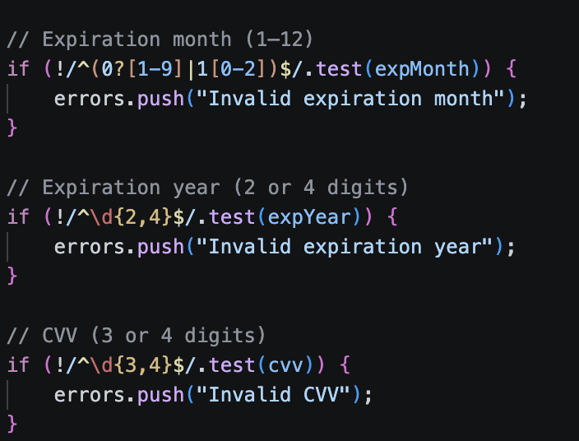
Diagram 10
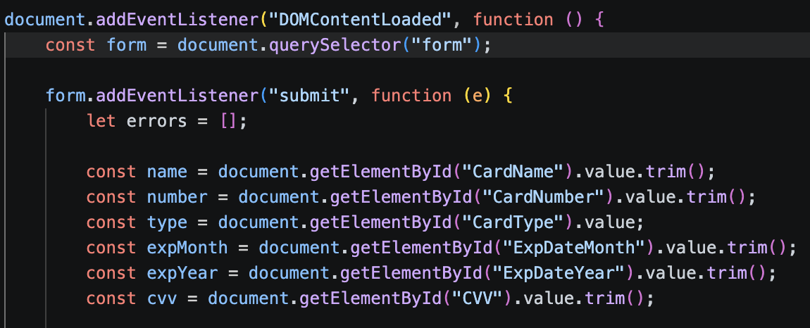
Diagram 11
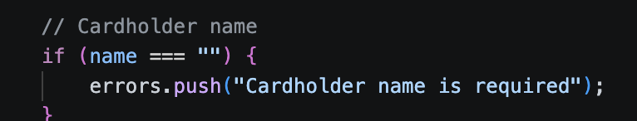
Diagram 12
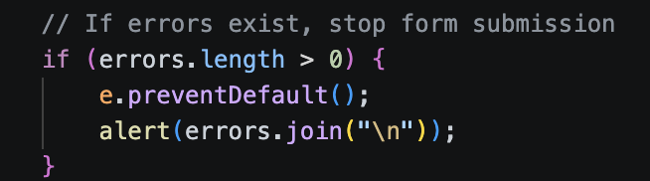
Diagram 13: result of an invalid response from payment.html
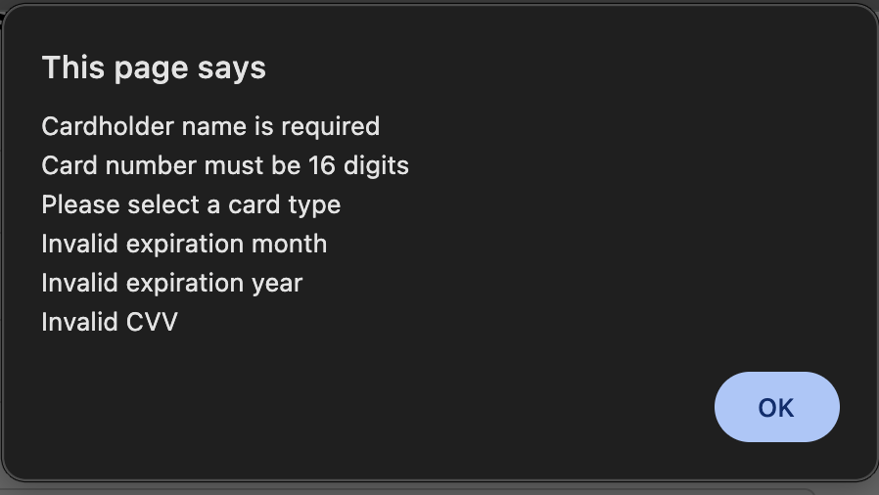

Choose plan
My choose plan page has no jQuery or JavaScript code as it had no need for such code as the page.

Choose plan CSS
Diagram 14

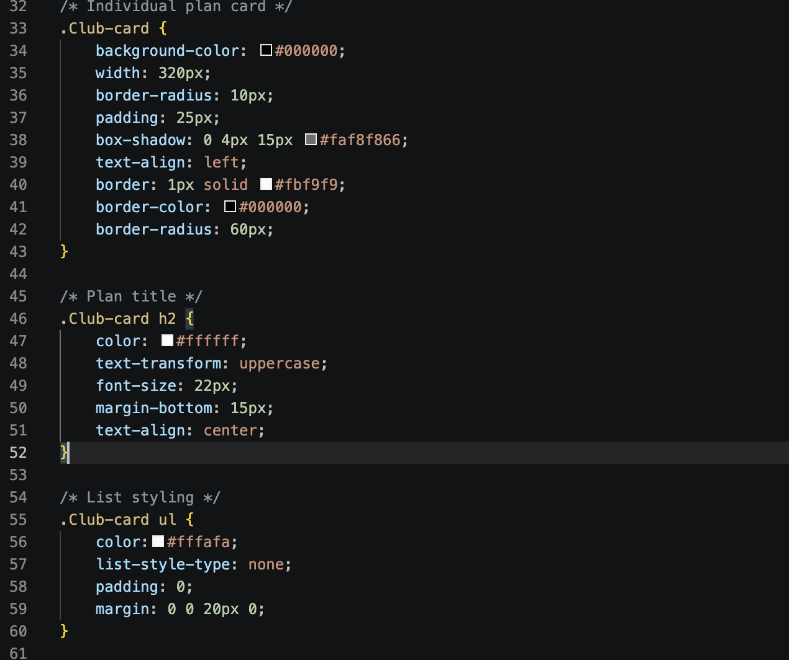
Diagram 15
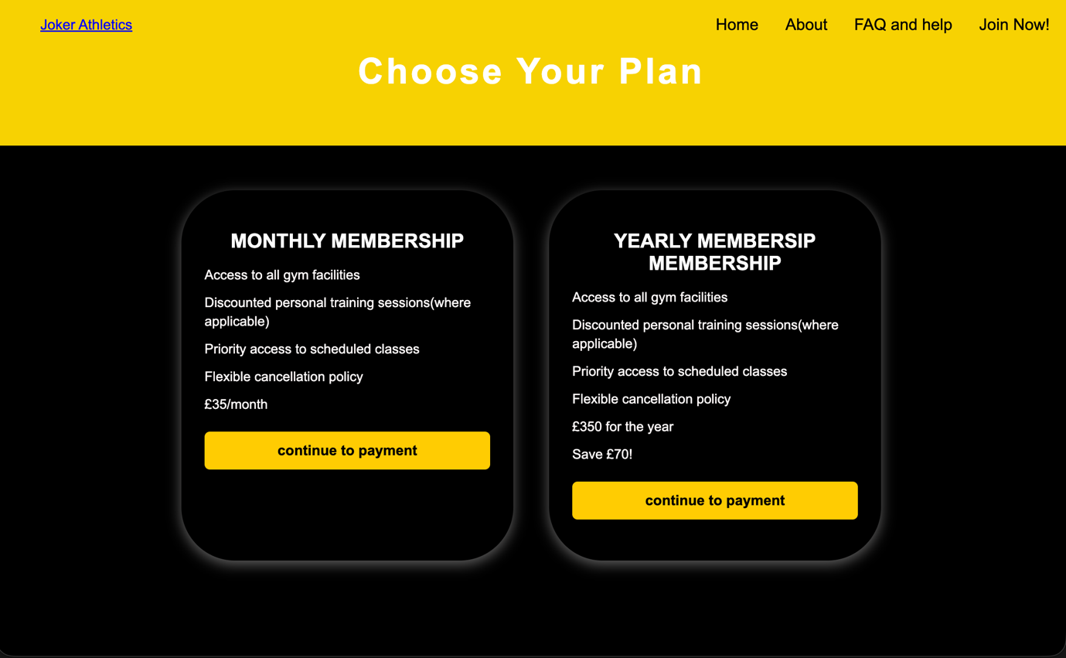
I have used a specific club card class to specifically target the membership boxes with rounded boxes, box shadow and padding to give it depth and clear separation between each box making them clear. Additionally, I have used a plan-container to encapsulate box boxes thus aligning plans neatly as see in diagram 14.

Classes CSS
Diagram 16
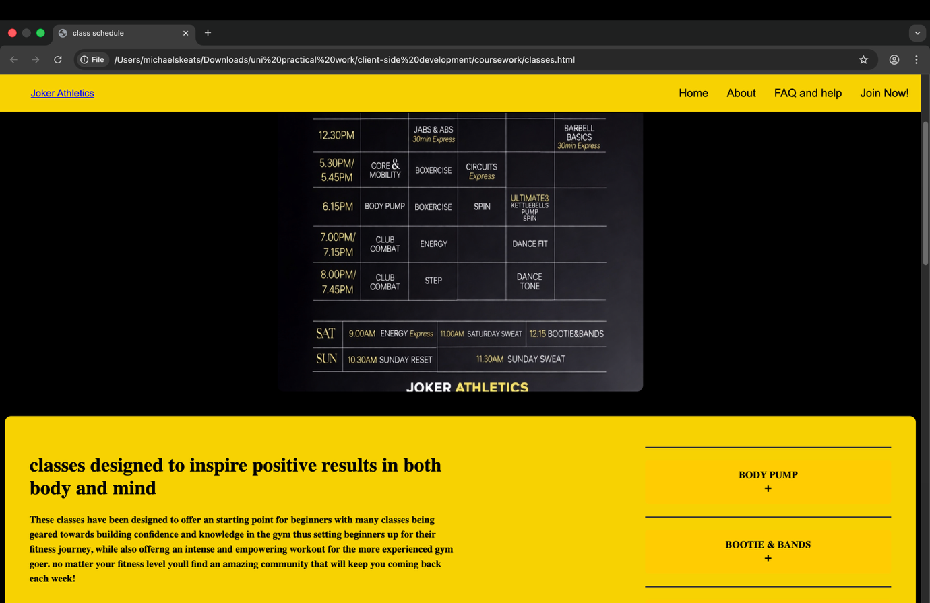

Diagram 18/19
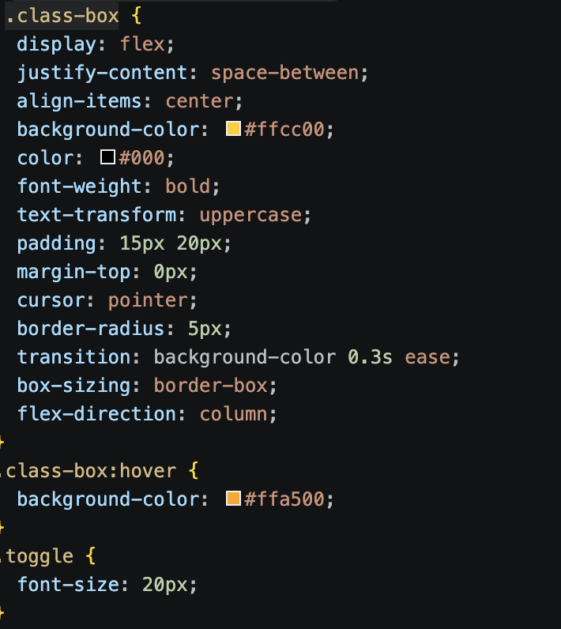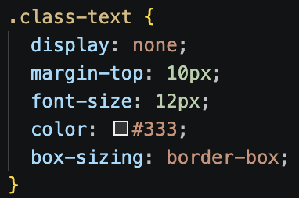
I have made use of interactive elements such “class box.hover” in Diagram 16 to enable the class boxes to change colour on hover thus improving user engagement and so colour blind can more easily see if the button is functional or not. Additionally, in the css I have class text set to display: none meaning that when the page is initially opened none of the class text is shown and is toggled using the previously mentioned jQuery function which is common practice in UI design.

Membership details CSS
In the membership details page, I have utilised stylised from inputs/ Labels as all inputs and dropdowns are full-width making it easily used on both mobile and computer thus increasing usability as any user is able to easily use this form. Furthermore, Labels are in bold and spaced which improves readability for users making it clear which input is expected in each section.
Diagram 20
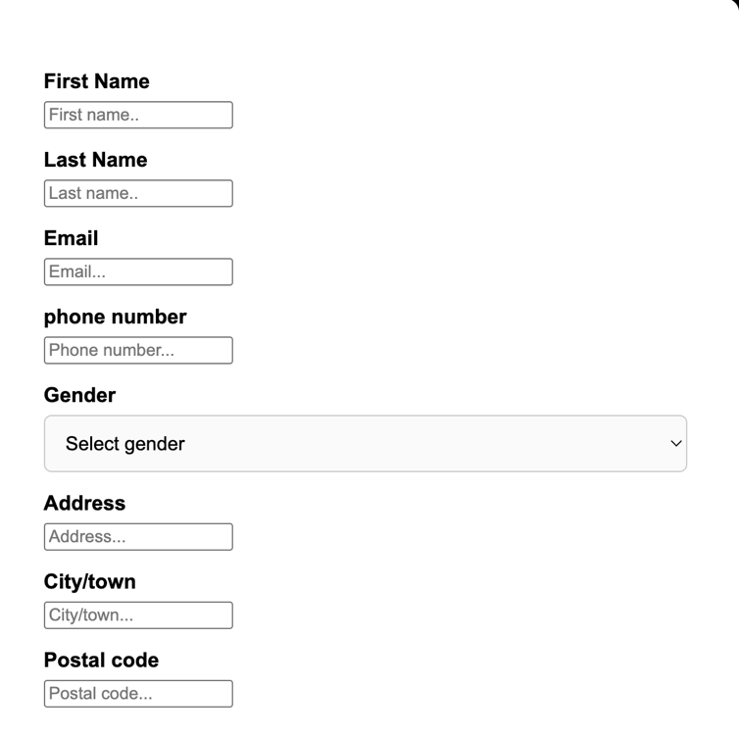

Payment CSS
In this css document I have made usage of checkout button styling which helps the button stand out clearly against the white form preventing any confusion on how to proceed past the checkout page. Additionally, I have made use of interaction affects (diagram 20) which guides the user to what they are interacting with on the page thus improving usability and accessibility as users can easily see where they are on the page

Diagram 21
